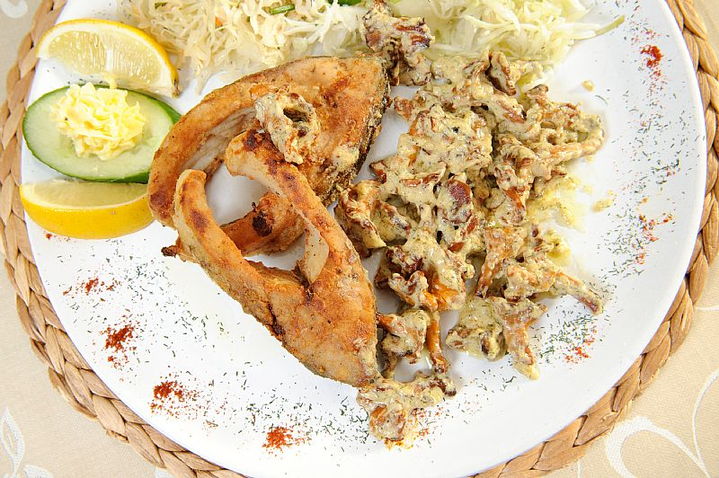
Activity One
Complete the recipe with the correct word and make a list of ingredients necessary to prepare ths delicious dish.
slightly/sprinkle/wrap/slices/rinse
Cut the carp into………….., rinse them, add salt and pepper, coat with breadcrumbs and fry the fish in hot oil. …………..the chanterelles, cut the big ones, fry them ………………in butter, add salt and pepper, pour over sweet cream, ……………………lemon juice and add fresh or dried, finely chopped dill. Put a browned slice of carp on a plate and ……………..it with mushrooms.
Ingredients:
……………………………….. ………………………………….
……………………………….. ………………………………….
………………………………… …………………………………..
………………………………… ……………………………………
………………………………… ……………………………………
Activity Two
Find the vocabulary in the recipe that will match their Polish equivalents._______________________
Opłukać
Obtoczyć
Bułka tarta
Skropić
Dokładnie posiekany
Koper

Activity Three
Work in groups and prepare a recipe for a dish with carp or other freshwater fish you like.

…………………………………………………………………………………………………………………………………………………………..

……………………………………………………………………………………………………………………………………………………………

……………………………………………………………………………………………………………………………………………………………

……………………………………………………………………………………………………………………………………………………………

……………………………………………………………………………………………………………………………………………………………

…………………………………………………………………………………………………………………………………………………………

