Singing in the rain
Sammy Davis Jr

1. Check up the following words in a dictionary.

RAIN - .........................................................
CLOUDS - .........................................................
HEART - .........................................................
GLORIOUS FEELING - .........................................................
LAUGH AT - .........................................................
RAIN - .........................................................
DARK - .........................................................
READY FOR - .........................................................

2. Listen to the FIRST PART of the song and put the sentences in the ocrrect order.
The sun's in my heart What a glorious feeling
And I'm ready for love. I'm happy again.

I'm singing in the rain I'm laughing at clouds
Just singing in the rain. So dark up above.

3. Rewrite the lyrics in the correct order.

............................................................................................................................................
............................................................................................................................................
............................................................................................................................................
............................................................................................................................................
............................................................................................................................................
............................................................................................................................................
............................................................................................................................................
............................................................................................................................................
4. Listen to the SECOND PART of the song.
Let the stormy clouds chase.
Everyone from the place
Come on with the rain
I've a smile on my face
I walk down the lane
With a happy refrain
Just singing...
Just singing in the rain.

Don’t go near the water
Johnny Cash
FOUNTAIN MOUNTAINS HILLS CITY DEAD FISH SHORE
1. Write the correct words under pictures.
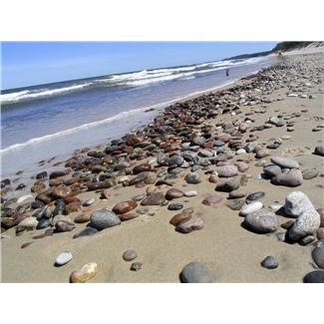
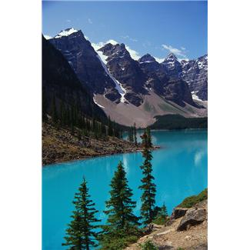

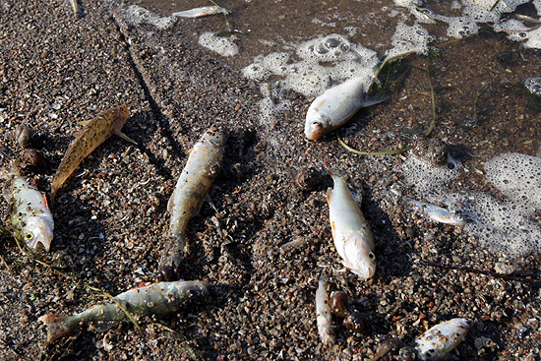

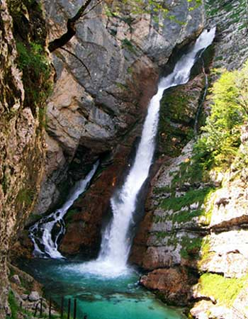



2. Match.
COOL
BRUDNY / SUCIO

CLEAR
ZANIECZYSZCZONY / CONTAMINADO

DIRTY
NIEBIESKI /AZUL

BLUE
CHŁODNY / FRESCO

GREY
SZARY / GRIS

POISONED
POLLUTED
ZATRUTY / ENVENENDADO

CZYSTY / LIMPIO

3. Work in pairs. Translate the vocabulary below. Then, use the vocabulary from exercises 1 and 2 and the vocabulary below to translate the first part of the song into Polish/Spanish.

*to run - ............................................... *to get down to - ...............................................
*to flow down - ............................................... *to turn into - ...............................................
*to go down - ............................................... *to flow along - ...............................................
*to pass through - ............................................... *to go near - ...............................................

From the fountains in the mountains ..............................................................................................
comes the water running ..............................................................................................
cool and clear and blue ..............................................................................................
And it flows down from the hills ..............................................................................................
and it goes down to the towns and passes through ..............................................................................................
When it gets down to the cities ..............................................................................................
then the water turns into a dirty grey ..............................................................................................
It's poisoned and polluted by the people ..............................................................................................
as it flows along its way ..............................................................................................
Don't go near the water children ..............................................................................................
see the fish all dead upon the shore ..............................................................................................
Don't go near the water – ..............................................................................................
the water isn't water anymore ..............................................................................................

4. Listen to the first part of the song.

5. Read the next part of the song and decide if the sentences below are TRUE or FALSE.

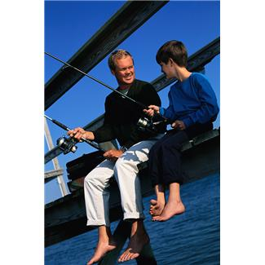
I took my boy fishing to my old favorite fishing hole.
I had caught many fish out of that deep clear water from the time I was a boy like him.
After we'd fished a few minutes he said:
- Did you get a bite yet daddy?
I said:
- I think I got a nibble son.
- Me too - he said.
Then he said:
- Daddy if we catch a fish can we eat him?
I said:
- Well there was a time son. This water's bad now and it might not be safe to eat the fish but there was a time...

 |  | TRUE | FALSE
1. | The father took his son fishing to a place where he used to fish as a child.
2. | They have already cought some fish.
3. | The water is as clean as it was in the past.
6. Listen to the second part of the song.

7. Check the meaning of the words below. Then, listen to the last part of the song and fill in the missing words.
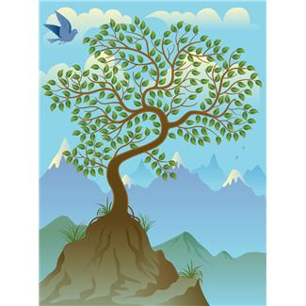
ACID RAIN
...................................
EARTH
....................

WIND
......................


SEA
......................

NATURE
............................
AIR
....................

There was a time the ...................... was clean and you could see forever cross the plains.
The ......................was sweet as honey and no one had ever heard of .......................
We're torturing the ...................... and pouring every kind of evil in the ...................... .
We violated ...................... and our children have to pay the penalty.

8. Which sentence is the best summary of the song’s lyrics.
- Today the water is as clean as it was in the past.
- In the past people used to go fishing more often.
- In the past the nature was clean but people have polluted and destroyed it.

