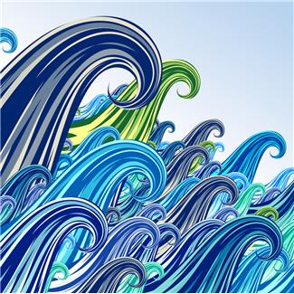

I. Write the definitions of the following bodies of water.

A lake is......................................................................................................

A sea is ......................................................................................................

A river is ......................................................................................................

A pond is .....................................................................................................

A ocean is ....................................................................................................

A bay is ....................................................................................................

- a protected body of saltwater
- a flowing body of freshwater
- a large body of saltwater
- a large body of freshwater
- a large body of very deep water
- a shallow body of still water

Source: http://bogglesworldesl.com/

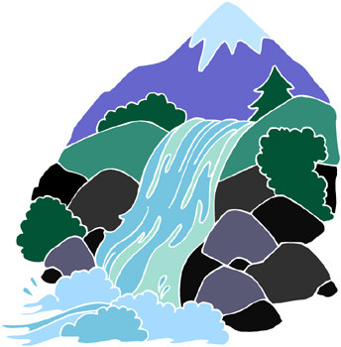
Rivers

I. Complete the crossword.

Across:
- The start of a river.
- The end of the river;
- The bottom of the river.
- The side of a river.

Down:
- The largest river in the world.
- The longest river in the world.
- Something that goes over a river.
- It sometimes happens after very heavy rains.

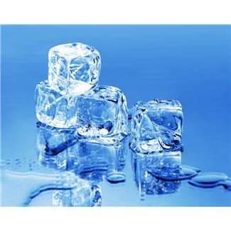
II. Complete the crossword.
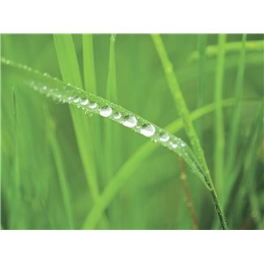
 |  |  |  |  |  |  |  | 1 | R
 |  |  |  |  |  |  |  | 2 | I
 |  |  |  |  |  |  |  | 3 | V
 |  |  |  |  |  |  | 4 |  | E |  |  | 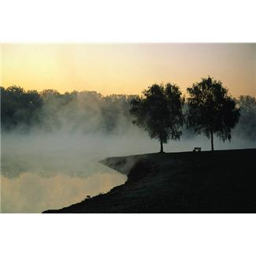
 |  |  |  |  |  | 5 |  |  | R
 |  |  |  |  |  |  |  | 6 | B
7 |  |  |  |  |  |  |  |  | E
 |  |  |  |  |  |  |  | 8 | D
8
5
3

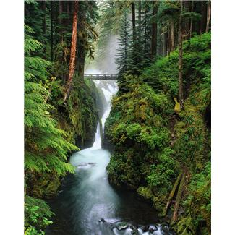
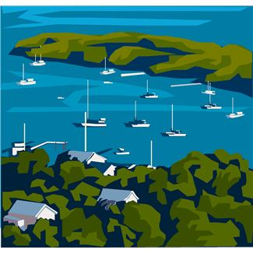

4
1
7
6
2
4

