I. Fill in the Water Cycle.

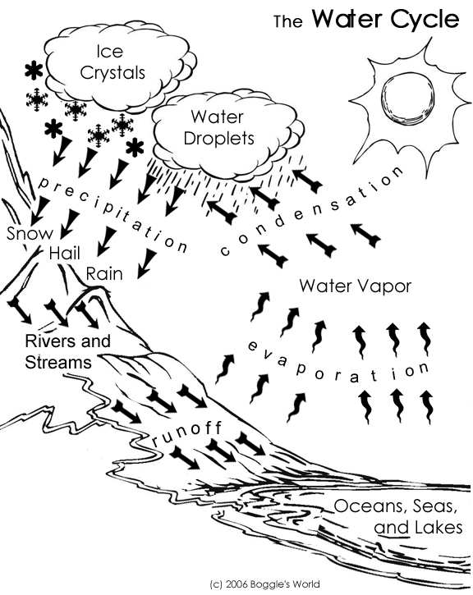

*RAIN *RIVERS AND STREAMS *WATER DROPLETS
*SNOW *WATER VAPOUR*HAIL
*ICE CRYSTALS *OCEANS, SEAS AND LAKES
.................
................
................

.........................................

........................................................................
..........................................

..........................................

.................................................

II. Complete the sentences with the correct verbs in the box.

goes uprains cools down forms
makes falls comes heats

- The sun ............................. the water.
- The water ............................. to the sky as vapour.
- Vapour ............................. clouds.
- Vapour in clouds ............................. and ............................. the rain.
- Water ............................. back to the Earth as rain.

III. Can you find these words?
WATER
SUN
VAPOUR
RAIN
CLOUDS
SKY

W | V | Z | R | A | I | N | D
A | O | A | F | P | B | C | N
T | M | N | P | K | H | S | C
E | T | V | B | O | K | U | C
R | C | F | Q | M | U | N | I
C | L | O | U | D | S | R | Y
P | M | N | B | S | K | Y | B
A | S | C | V | V | Y | B | A

Source: http://bogglesworldesl.com/

IV. Find the words below in the grid.

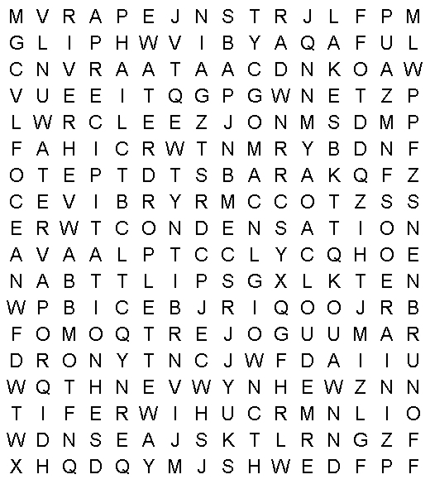 |  |  | 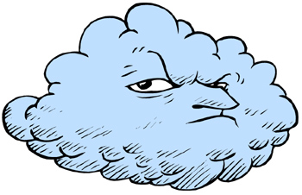  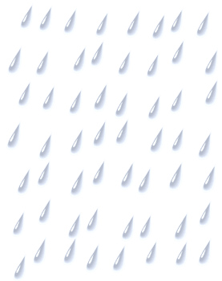
cloud  condensation  energy  evaporation  hail  ice crystal  lake | ocean  precipitation  rain  river  runoff  sea  snow | stream  sun  water cycle  water droplet  water vapor  wind
Source: http://bogglesworldesl.com/

